**Internship Documentation :**

**Company Name : Akash Technolab**

**Internship technology : PHP**

**Submitted By : Ronakbhai Bharatbhai Bhalala**

**Date :03/06/21**

**Task 8 :**

**config.php**

**this file is used for an creating an connection this is called an database configuration file.**

<?php

define('DB_SERVER', 'localhost');

define('DB_USERNAME', 'root');

define('DB_PASSWORD', '');

define('DB_NAME', 'demo');

/* Attempt to connect to MySQL database */

$link = mysqli_connect(DB_SERVER, DB_USERNAME, DB_PASSWORD, DB_NAME);

// Check connection

if($link === false){

die("ERROR: Could not connect. " . mysqli_connect_error());

}

?>

**Index.php**

**This is an main homepage for application.**

**Program:**

<!DOCTYPE html>

<html lang="en">

<head>

<meta charset="UTF-8">

<title>Dashboard</title>

<link rel="stylesheet" href="https://stackpath.bootstrapcdn.com/bootstrap/4.5.2/css/bootstrap.min.css">

<link rel="stylesheet" href="https://maxcdn.bootstrapcdn.com/font-awesome/4.7.0/css/font-awesome.min.css">

<script src="https://code.jquery.com/jquery-3.5.1.min.js"></script>

<script src="https://cdn.jsdelivr.net/npm/popper.js@1.16.1/dist/umd/popper.min.js"></script>

<script src="https://stackpath.bootstrapcdn.com/bootstrap/4.5.2/js/bootstrap.min.js"></script>

<style>

.wrapper{

width: 600px;

margin: 0 auto;

}

table tr td:last-child{

width: 120px;

}

</style>

<script>

$(document).ready(function(){

$('[data-toggle="tooltip"]').tooltip();

});

</script>

</head>

<body>

<div class="wrapper">

<div class="container-fluid">

<div class="row">

<div class="col-md-12">

<div class="mt-5 mb-3 clearfix">

<h2 class="pull-left">Employees Details</h2>

<a href="create.php" class="btn btn-success pull-right"><i class="fa fa-plus"></i> Add New Employee</a>

</div>

<?php

// Include config file

require_once "config.php";

// Attempt select query execution

$sql = "SELECT * FROM employees";

if($result = mysqli_query($link, $sql)){

if(mysqli_num_rows($result) > 0){

echo '<table class="table table-bordered table-striped">';

echo "<thead>";

echo "<tr>";

echo "<th>#</th>";

echo "<th>Name</th>";

echo "<th>Address</th>";

echo "<th>Salary</th>";

echo "<th>Action</th>";

echo "</tr>";

echo "</thead>";

echo "<tbody>";

while($row = mysqli_fetch_array($result)){

echo "<tr>";

echo "<td>" . $row['id'] . "</td>";

echo "<td>" . $row['name'] . "</td>";

echo "<td>" . $row['address'] . "</td>";

echo "<td>" . $row['salary'] . "</td>";

echo "<td>";

echo '<a href="read.php?id='. $row['id'] .'" class="mr-3" title="View Record" data-toggle="tooltip"><span class="fa fa-eye"></span></a>';

echo '<a href="update.php?id='. $row['id'] .'" class="mr-3" title="Update Record" data-toggle="tooltip"><span class="fa fa-pencil"></span></a>';

echo '<a href="delete.php?id='. $row['id'] .'" title="Delete Record" data-toggle="tooltip"><span class="fa fa-trash"></span></a>';

echo "</td>";

echo "</tr>";

}

echo "</tbody>";

echo "</table>";

// Free result set

mysqli_free_result($result);

} else{

echo '<div class="alert alert-danger"><em>No records were found.</em></div>';

}

} else{

echo "Oops! Something went wrong. Please try again later.";

}

// Close connection

mysqli_close($link);

?>

</div>

</div>

</div>

</div>

<p style="margin-left:30%">Search records Here <?php include('search-form.php');?></p>

</body>

</html>

**Output:**

Initial stage of application with out inserting records.

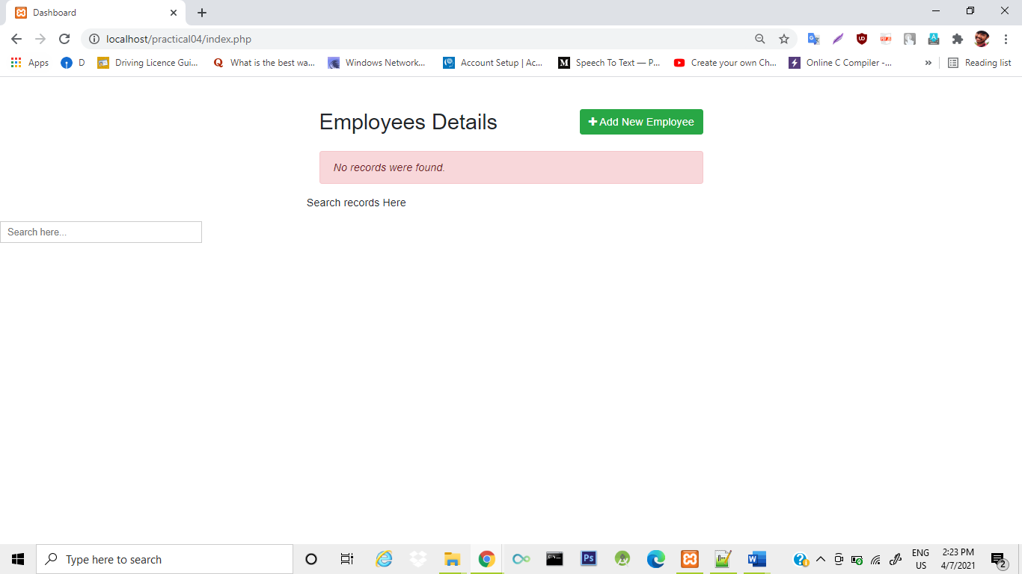

**create.php**

**this file is use for an inserting record**

<?php

// Include config file

require_once "config.php";

// Define variables and initialize with empty values

$name = $address = $salary = "";

$name_err = $address_err = $salary_err = "";

// Processing form data when form is submitted

if($_SERVER["REQUEST_METHOD"] == "POST"){

// Validate name

$input_name = trim($_POST["name"]);

if(empty($input_name)){

$name_err = "Please enter a name.";

} elseif(!filter_var($input_name, FILTER_VALIDATE_REGEXP, array("options"=>array("regexp"=>"/^[a-zA-Z\s]+$/")))){

$name_err = "Please enter a valid name.";

} else{

$name = $input_name;

}

// Validate address

$input_address = trim($_POST["address"]);

if(empty($input_address)){

$address_err = "Please enter an address.";

} else{

$address = $input_address;

}

// Validate salary

$input_salary = trim($_POST["salary"]);

if(empty($input_salary)){

$salary_err = "Please enter the salary amount.";

} elseif(!ctype_digit($input_salary)){

$salary_err = "Please enter a positive integer value.";

} else{

$salary = $input_salary;

}

// Check input errors before inserting in database

if(empty($name_err) && empty($address_err) && empty($salary_err)){

// Prepare an insert statement

$sql = "INSERT INTO employees (name, address, salary) VALUES (?, ?, ?)";

if($stmt = mysqli_prepare($link, $sql)){

// Bind variables to the prepared statement as parameters

mysqli_stmt_bind_param($stmt, "sss", $param_name, $param_address, $param_salary);

// Set parameters

$param_name = $name;

$param_address = $address;

$param_salary = $salary;

// Attempt to execute the prepared statement

if(mysqli_stmt_execute($stmt)){

// Records created successfully. Redirect to landing page

header("location: index.php");

exit();

} else{

echo "Oops! Something went wrong. Please try again later.";

}

}

// Close statement

mysqli_stmt_close($stmt);

}

// Close connection

mysqli_close($link);

}

?>

<!DOCTYPE html>

<html lang="en">

<head>

<meta charset="UTF-8">

<title>Create Record</title>

<link rel="stylesheet" href="https://stackpath.bootstrapcdn.com/bootstrap/4.5.2/css/bootstrap.min.css">

<style>

.wrapper{

width: 600px;

margin: 0 auto;

}

</style>

</head>

<body>

<div class="wrapper">

<div class="container-fluid">

<div class="row">

<div class="col-md-12">

<h2 class="mt-5">Create Record</h2>

<p>Please fill this form and submit to add employee record to the database.</p>

<form action="<?php echo htmlspecialchars($_SERVER["PHP_SELF"]); ?>" method="post">

<div class="form-group">

<label>Name</label>

<input type="text" name="name" class="form-control <?php echo (!empty($name_err)) ? 'is-invalid' : ''; ?>" value="<?php echo $name; ?>">

<span class="invalid-feedback"><?php echo $name_err;?></span>

</div>

<div class="form-group">

<label>Address</label>

<textarea name="address" class="form-control <?php echo (!empty($address_err)) ? 'is-invalid' : ''; ?>"><?php echo $address; ?></textarea>

<span class="invalid-feedback"><?php echo $address_err;?></span>

</div>

<div class="form-group">

<label>Salary</label>

<input type="text" name="salary" class="form-control <?php echo (!empty($salary_err)) ? 'is-invalid' : ''; ?>" value="<?php echo $salary; ?>">

<span class="invalid-feedback"><?php echo $salary_err;?></span>

</div>

<input type="submit" class="btn btn-primary" value="Submit">

<a href="index.php" class="btn btn-secondary ml-2">Cancel</a>

</form>

</div>

</div>

</div>

</div>

</body>

</html>

**Output:**

For insert operation click on add new operation.



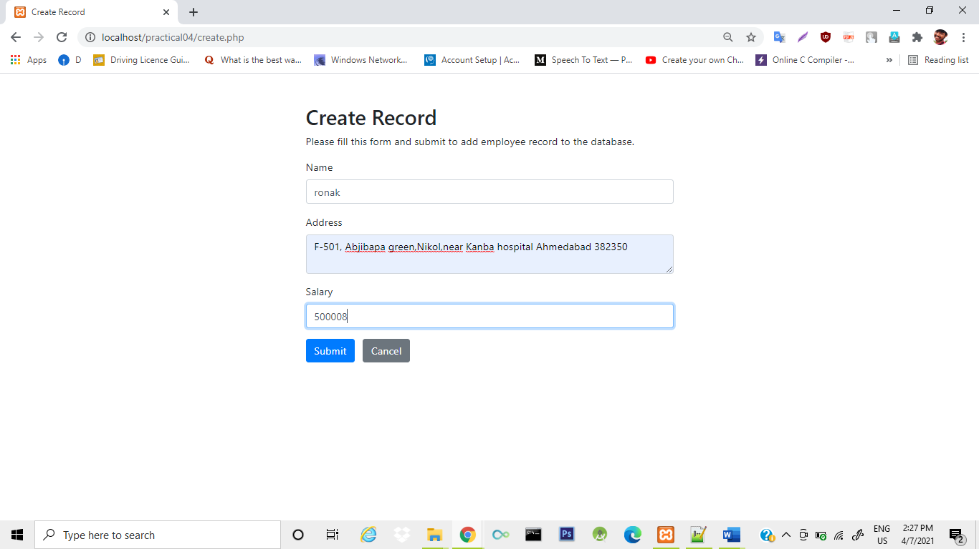

**After click on submit record will be inserted.**

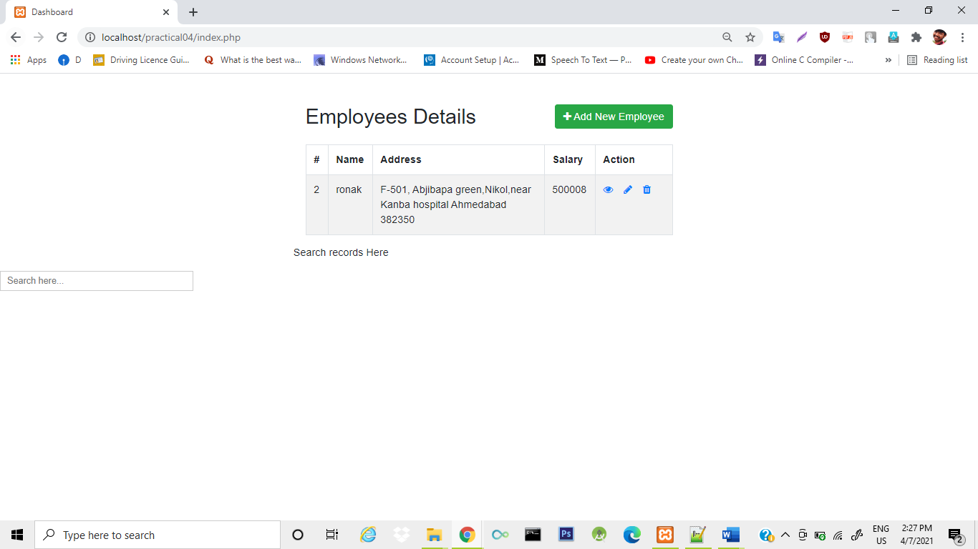

**read.php**

**for viewing a records.**

**Program:**

<?php

// Check existence of id parameter before processing further

if(isset($_GET["id"]) && !empty(trim($_GET["id"]))){

// Include config file

require_once "config.php";

// Prepare a select statement

$sql = "SELECT * FROM employees WHERE id = ?";

if($stmt = mysqli_prepare($link, $sql)){

// Bind variables to the prepared statement as parameters

mysqli_stmt_bind_param($stmt, "i", $param_id);

// Set parameters

$param_id = trim($_GET["id"]);

// Attempt to execute the prepared statement

if(mysqli_stmt_execute($stmt)){

$result = mysqli_stmt_get_result($stmt);

if(mysqli_num_rows($result) == 1){

/* Fetch result row as an associative array. Since the result set

contains only one row, we don't need to use while loop */

$row = mysqli_fetch_array($result, MYSQLI_ASSOC);

// Retrieve individual field value

$name = $row["name"];

$address = $row["address"];

$salary = $row["salary"];

} else{

// URL doesn't contain valid id parameter. Redirect to error page

header("location: error.php");

exit();

}

} else{

echo "Oops! Something went wrong. Please try again later.";

}

}

// Close statement

mysqli_stmt_close($stmt);

// Close connection

mysqli_close($link);

} else{

// URL doesn't contain id parameter. Redirect to error page

header("location: error.php");

exit();

}

?>

<!DOCTYPE html>

<html lang="en">

<head>

<meta charset="UTF-8">

<title>View Record</title>

<link rel="stylesheet" href="https://stackpath.bootstrapcdn.com/bootstrap/4.5.2/css/bootstrap.min.css">

<style>

.wrapper{

width: 600px;

margin: 0 auto;

}

</style>

</head>

<body>

<div class="wrapper">

<div class="container-fluid">

<div class="row">

<div class="col-md-12">

<h1 class="mt-5 mb-3">View Record</h1>

<div class="form-group">

<label>Name</label>

<p><b><?php echo $row["name"]; ?></b></p>

</div>

<div class="form-group">

<label>Address</label>

<p><b><?php echo $row["address"]; ?></b></p>

</div>

<div class="form-group">

<label>Salary</label>

<p><b><?php echo $row["salary"]; ?></b></p>

</div>

<p><a href="index.php" class="btn btn-primary">Back</a></p>

</div>

</div>

</div>

</div>

</body>

</html>

**Output:**

**Click on the eye icon for read an records.**



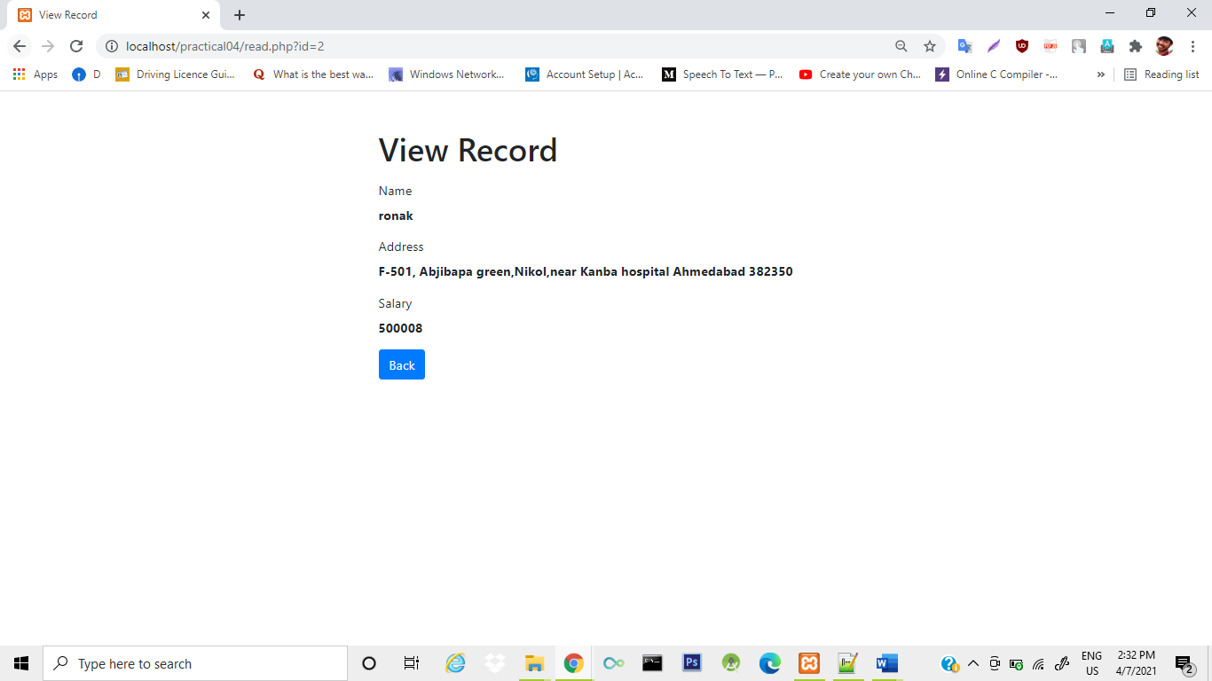

**update.php**

**Program:**

<?php

// Include config file

require_once "config.php";

// Define variables and initialize with empty values

$name = $address = $salary = "";

$name_err = $address_err = $salary_err = "";

// Processing form data when form is submitted

if(isset($_POST["id"]) && !empty($_POST["id"])){

// Get hidden input value

$id = $_POST["id"];

// Validate name

$input_name = trim($_POST["name"]);

if(empty($input_name)){

$name_err = "Please enter a name.";

} elseif(!filter_var($input_name, FILTER_VALIDATE_REGEXP, array("options"=>array("regexp"=>"/^[a-zA-Z\s]+$/")))){

$name_err = "Please enter a valid name.";

} else{

$name = $input_name;

}

// Validate address address

$input_address = trim($_POST["address"]);

if(empty($input_address)){

$address_err = "Please enter an address.";

} else{

$address = $input_address;

}

// Validate salary

$input_salary = trim($_POST["salary"]);

if(empty($input_salary)){

$salary_err = "Please enter the salary amount.";

} elseif(!ctype_digit($input_salary)){

$salary_err = "Please enter a positive integer value.";

} else{

$salary = $input_salary;

}

// Check input errors before inserting in database

if(empty($name_err) && empty($address_err) && empty($salary_err)){

// Prepare an update statement

$sql = "UPDATE employees SET name=?, address=?, salary=? WHERE id=?";

if($stmt = mysqli_prepare($link, $sql)){

// Bind variables to the prepared statement as parameters

mysqli_stmt_bind_param($stmt, "sssi", $param_name, $param_address, $param_salary, $param_id);

// Set parameters

$param_name = $name;

$param_address = $address;

$param_salary = $salary;

$param_id = $id;

// Attempt to execute the prepared statement

if(mysqli_stmt_execute($stmt)){

// Records updated successfully. Redirect to landing page

header("location: index.php");

exit();

} else{

echo "Oops! Something went wrong. Please try again later.";

}

}

// Close statement

mysqli_stmt_close($stmt);

}

// Close connection

mysqli_close($link);

} else{

// Check existence of id parameter before processing further

if(isset($_GET["id"]) && !empty(trim($_GET["id"]))){

// Get URL parameter

$id = trim($_GET["id"]);

// Prepare a select statement

$sql = "SELECT * FROM employees WHERE id = ?";

if($stmt = mysqli_prepare($link, $sql)){

// Bind variables to the prepared statement as parameters

mysqli_stmt_bind_param($stmt, "i", $param_id);

// Set parameters

$param_id = $id;

// Attempt to execute the prepared statement

if(mysqli_stmt_execute($stmt)){

$result = mysqli_stmt_get_result($stmt);

if(mysqli_num_rows($result) == 1){

/* Fetch result row as an associative array. Since the result set

contains only one row, we don't need to use while loop */

$row = mysqli_fetch_array($result, MYSQLI_ASSOC);

// Retrieve individual field value

$name = $row["name"];

$address = $row["address"];

$salary = $row["salary"];

} else{

// URL doesn't contain valid id. Redirect to error page

header("location: error.php");

exit();

}

} else{

echo "Oops! Something went wrong. Please try again later.";

}

}

// Close statement

mysqli_stmt_close($stmt);

// Close connection

mysqli_close($link);

} else{

// URL doesn't contain id parameter. Redirect to error page

header("location: error.php");

exit();

}

}

?>

<!DOCTYPE html>

<html lang="en">

<head>

<meta charset="UTF-8">

<title>Update Record</title>

<link rel="stylesheet" href="https://stackpath.bootstrapcdn.com/bootstrap/4.5.2/css/bootstrap.min.css">

<style>

.wrapper{

width: 600px;

margin: 0 auto;

}

</style>

</head>

<body>

<div class="wrapper">

<div class="container-fluid">

<div class="row">

<div class="col-md-12">

<h2 class="mt-5">Update Record</h2>

<p>Please edit the input values and submit to update the employee record.</p>

<form action="<?php echo htmlspecialchars(basename($_SERVER['REQUEST_URI'])); ?>" method="post">

<div class="form-group">

<label>Name</label>

<input type="text" name="name" class="form-control <?php echo (!empty($name_err)) ? 'is-invalid' : ''; ?>" value="<?php echo $name; ?>">

<span class="invalid-feedback"><?php echo $name_err;?></span>

</div>

<div class="form-group">

<label>Address</label>

<textarea name="address" class="form-control <?php echo (!empty($address_err)) ? 'is-invalid' : ''; ?>"><?php echo $address; ?></textarea>

<span class="invalid-feedback"><?php echo $address_err;?></span>

</div>

<div class="form-group">

<label>Salary</label>

<input type="text" name="salary" class="form-control <?php echo (!empty($salary_err)) ? 'is-invalid' : ''; ?>" value="<?php echo $salary; ?>">

<span class="invalid-feedback"><?php echo $salary_err;?></span>

</div>

<input type="hidden" name="id" value="<?php echo $id; ?>"/>

<input type="submit" class="btn btn-primary" value="Submit">

<a href="index.php" class="btn btn-secondary ml-2">Cancel</a>

</form>

</div>

</div>

</div>

</div>

</body>

</html>

**Output:**

**Click on pen icon for update a record**



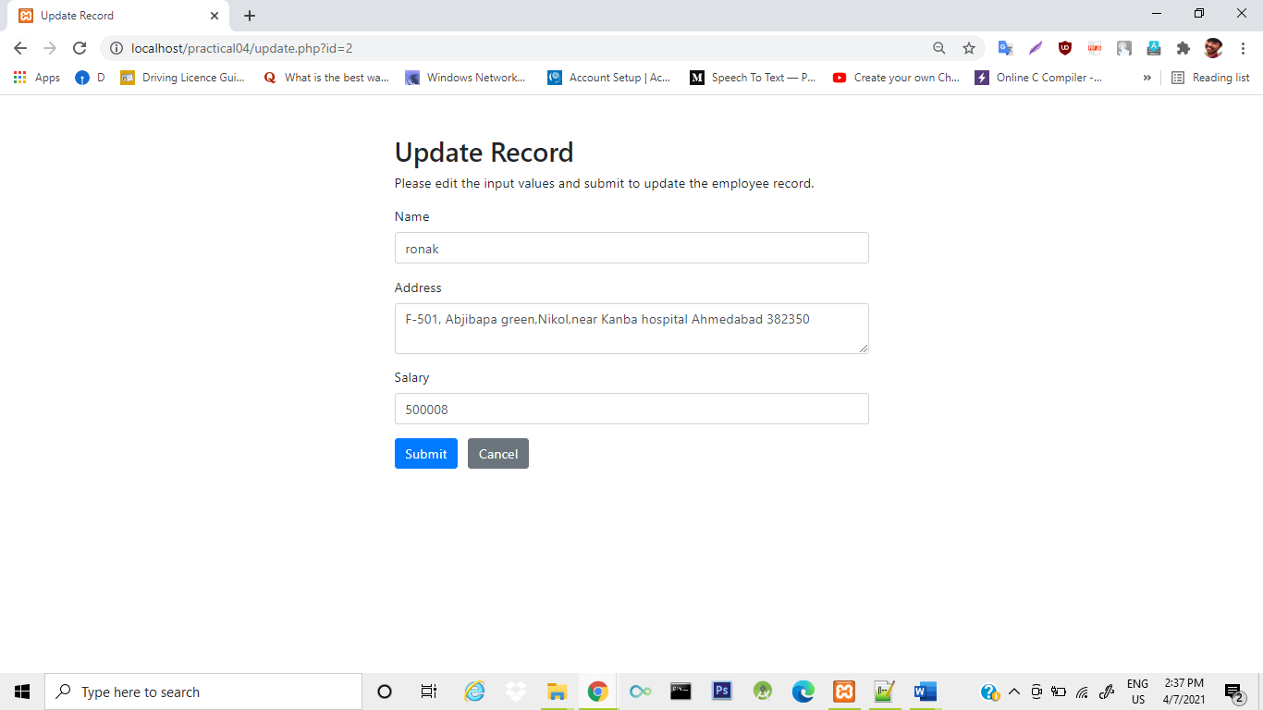

**delete.php**

**for perform deletion operation.**

**Program:**

<?php

// Process delete operation after confirmation

if(isset($_POST["id"]) && !empty($_POST["id"])){

// Include config file

require_once "config.php";

// Prepare a delete statement

$sql = "DELETE FROM employees WHERE id = ?";

if($stmt = mysqli_prepare($link, $sql)){

// Bind variables to the prepared statement as parameters

mysqli_stmt_bind_param($stmt, "i", $param_id);

// Set parameters

$param_id = trim($_POST["id"]);

// Attempt to execute the prepared statement

if(mysqli_stmt_execute($stmt)){

// Records deleted successfully. Redirect to landing page

header("location: index.php");

exit();

} else{

echo "Oops! Something went wrong. Please try again later.";

}

}

// Close statement

mysqli_stmt_close($stmt);

// Close connection

mysqli_close($link);

} else{

// Check existence of id parameter

if(empty(trim($_GET["id"]))){

// URL doesn't contain id parameter. Redirect to error page

header("location: error.php");

exit();

}

}

?>

<!DOCTYPE html>

<html lang="en">

<head>

<meta charset="UTF-8">

<title>Delete Record</title>

<link rel="stylesheet" href="https://stackpath.bootstrapcdn.com/bootstrap/4.5.2/css/bootstrap.min.css">

<style>

.wrapper{

width: 600px;

margin: 0 auto;

}

</style>

</head>

<body>

<div class="wrapper">

<div class="container-fluid">

<div class="row">

<div class="col-md-12">

<h2 class="mt-5 mb-3">Delete Record</h2>

<form action="<?php echo htmlspecialchars($_SERVER["PHP_SELF"]); ?>" method="post">

<div class="alert alert-danger">

<input type="hidden" name="id" value="<?php echo trim($_GET["id"]); ?>"/>

<p>Are you sure you want to delete this employee record?</p>

<p>

<input type="submit" value="Yes" class="btn btn-danger">

<a href="index.php" class="btn btn-secondary">No</a>

</p>

</div>

</form>

</div>

</div>

</div>

</div>

</body>

</html>

**Output:**

**First click on bean icon for delete a record.**



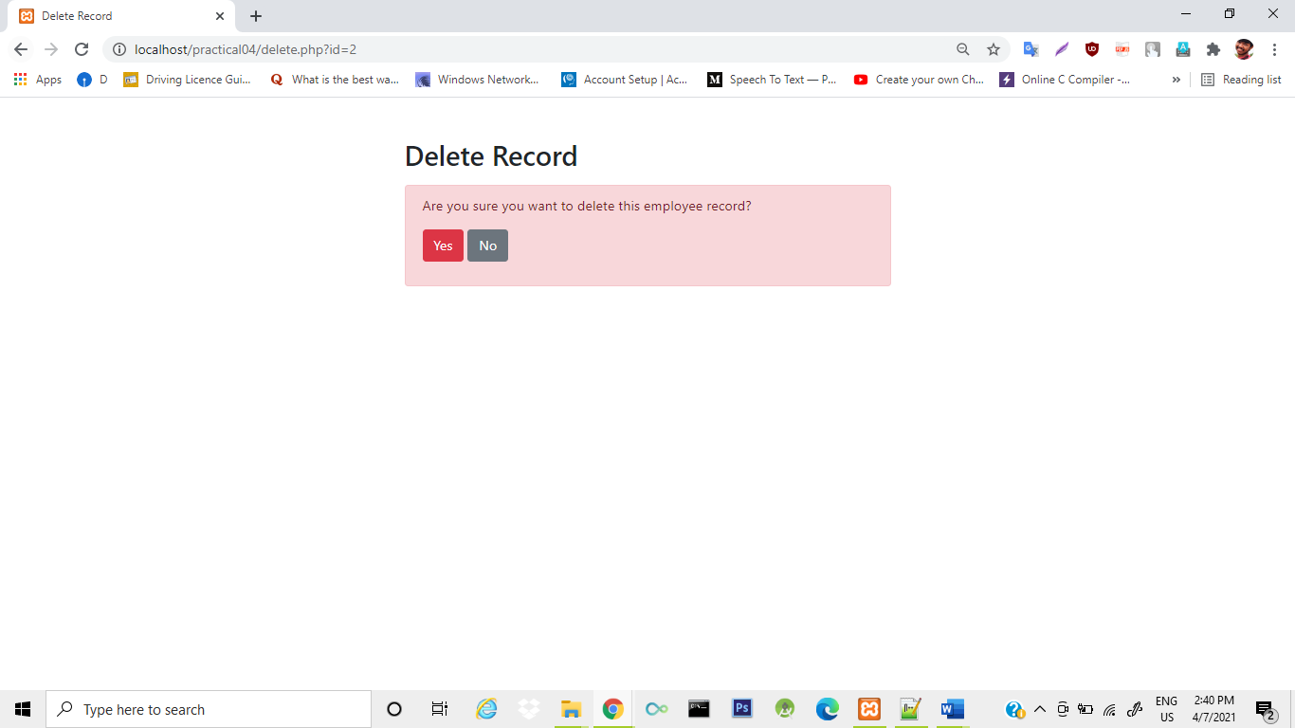

**Error.php**

**If error will occurred this page will be display**

**Program:**

<!DOCTYPE html>

<html lang="en">

<head>

<meta charset="UTF-8">

<title>Error</title>

<link rel="stylesheet" href="https://stackpath.bootstrapcdn.com/bootstrap/4.5.2/css/bootstrap.min.css">

<style>

.wrapper{

width: 600px;

margin: 0 auto;

}

</style>

</head>

<body>

<div class="wrapper">

<div class="container-fluid">

<div class="row">

<div class="col-md-12">

<h2 class="mt-5 mb-3">Invalid Request</h2>

<div class="alert alert-danger">Sorry, you've made an invalid request. Please <a href="index.php" class="alert-link">go back</a> and try again.</div>

</div>

</div>

</div>

</div>

</body>

</html>

**Output:**

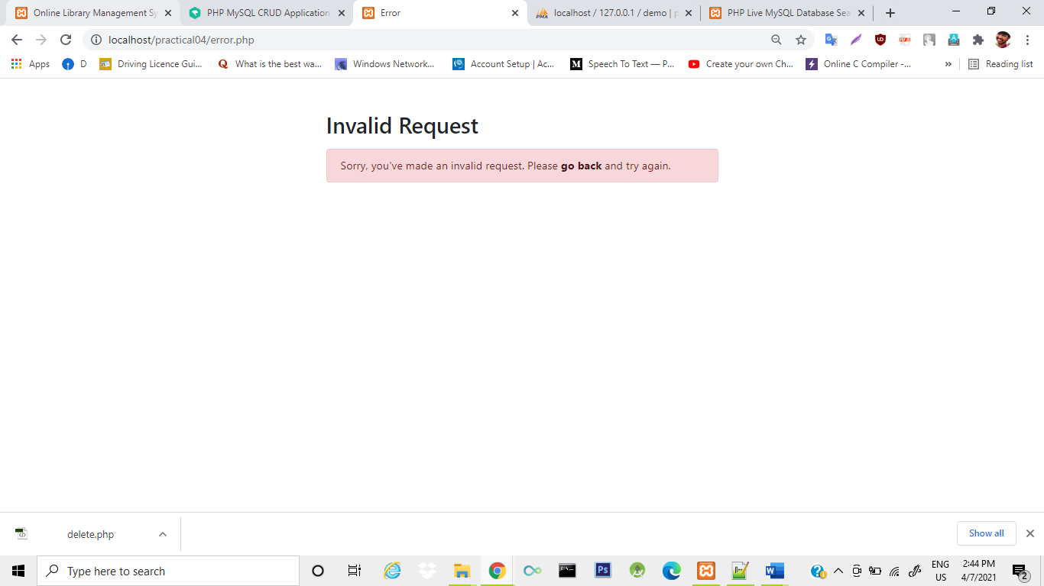

**Search.php**

**Program:**

<!DOCTYPE html>

<html lang="en">

<head>

<meta charset="UTF-8">

<title>PHP Live MySQL Database Search</title>

<style>

body{

font-family: Arail, sans-serif;

}

/* Formatting search box */

.search-box{

width: 300px;

position: relative;

display: inline-block;

font-size: 14px;

}

.search-box input[type="text"]{

height: 32px;

padding: 5px 10px;

border: 1px solid #CCCCCC;

font-size: 14px;

}

.result{

position: absolute;

z-index: 999;

top: 100%;

left: 0;

}

.search-box input[type="text"], .result{

width: 100%;

box-sizing: border-box;

}

/* Formatting result items */

.result p{

margin: 0;

padding: 7px 10px;

border: 1px solid #CCCCCC;

border-top: none;

cursor: pointer;

}

.result p:hover{

background: #f2f2f2;

}

</style>

<script src="https://code.jquery.com/jquery-3.5.1.min.js"></script>

<script>

$(document).ready(function(){

$('.search-box input[type="text"]').on("keyup input", function(){

/* Get input value on change */

var inputVal = $(this).val();

var resultDropdown = $(this).siblings(".result");

if(inputVal.length){

$.get("backend-search.php", {term: inputVal}).done(function(data){

// Display the returned data in browser

resultDropdown.html(data);

});

} else{

resultDropdown.empty();

}

});

// Set search input value on click of result item

$(document).on("click", ".result p", function(){

$(this).parents(".search-box").find('input[type="text"]').val($(this).text());

$(this).parent(".result").empty();

});

});

</script>

</head>

<body >

<div class="search-box">

<input type="text" autocomplete="off" style="margin-left=30%" placeholder="Search here..." />

<div class="result"></div>

</div>

</body>

</html>

**Output:**

